- How to view details of registered user (Nodal Officer) belonging to particular Ministry/Organisation?
- You may click on label ‘Nodal Officer info’ available at home page of the GLIS portal. Then using search option, you may get the desired information.

- Forgot the user ID and password to do login. What shall I do?
Kindly share the nodal officer and organization name on email @neelu.chaudhary@digitalindia.gov.in to receive the required information.

- How to view land data details mapped by organisations?
- Click on label ‘Report’ to view important details regarding land parcels mapped on GLIS portal.

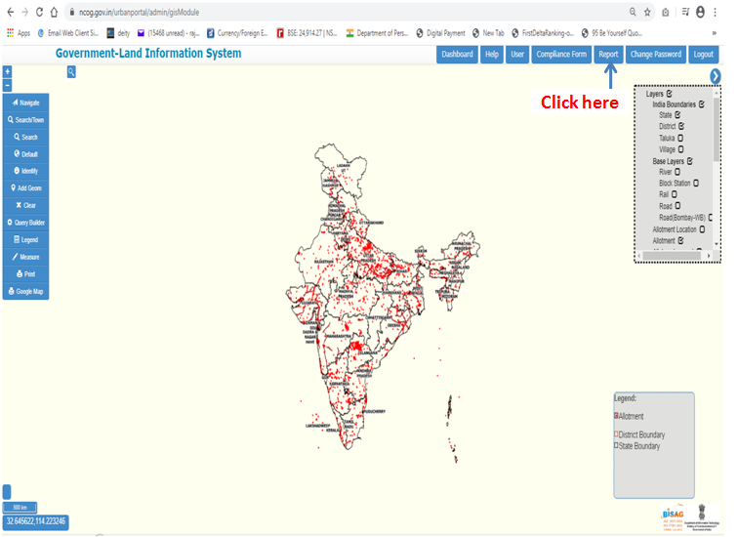

- Can I download the report containing details of land parcels mapped on GLIS portal?
- Yes, you may click on option of ‘Excel’ to download land details report.

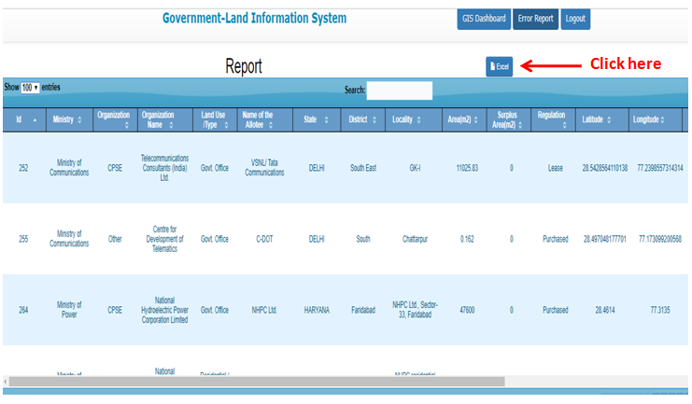

- How to download the map uploaded by user representing area under its organization?
- Click on option of ‘Download’ available in report section under column ‘Download file’.

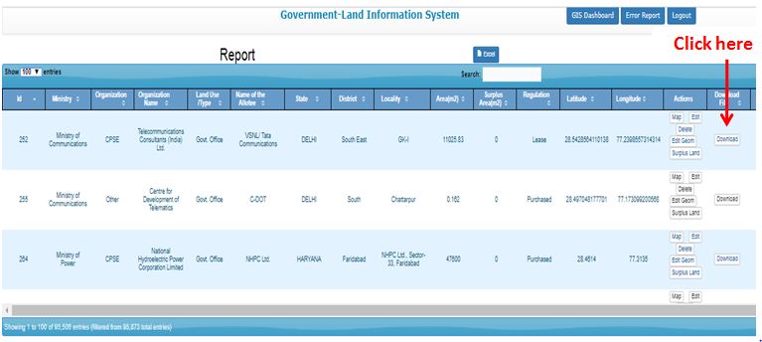

- How to map land details/building details on the GLIS portal?
Kindly see the user manual or training video for your reference.

FAR (Floor Area Ratio):

(a) F.A.R means Floor Area Ratio
(b) Definition of FAR;- The percentage of the total covered area with its plot area is known as FAR.
(c) Utilized FAR; The percentage of actual existing covered area of all floors (excluding basement) with its plot area is known as Utilized FAR.
(d) FAR - Available; The percentage of permissible covered area (as per bye-laws) with it’s plot area is known as FAR – Available.
Note; - The Area of basement is not to be included in FAR.
Example of (Utilized FAR); suppose plot area =5000 sq.mts
Total built up area on all floor (Excluding basement) = 7500 sq.mts
Utilized FAR =7500x100/5000= 150

Example of (FAR - Available); - Suppose plot area= 5000sq.mts
FAR - Available (as per bye laws) = 300
Total available covered area which can be sanctioned and achieved on all floors excluding basement = 300/100x5000= 15000 sq.mts.

